HTML AND CSS ASSIGNMENT

1. Question: What is the CSS Box Model, and how does it affect the layout of elements on a webpage? Exercise: Provide a simple HTML structure with a few elements and ask the students to apply CSS properties to manipulate the box model, such as margin, padding, and border.

ANSWER) The CSS Box Model is a fundamental concept in web design and development that defines how elements on a webpage are laid out and how their dimensions are calculated. It consists of four main components: content, padding, border, and margin. These components wrap around an HTML element, creating a "box" around it. Here's a brief explanation of each component:

1. Content: This is the innermost part of the box and contains the actual content of the element, such as text, images, or other HTML elements.

2. Padding: Padding is the space between the content and the border. It provides internal spacing within the element, separating the content from the border. You can set padding on all sides (top, right, bottom, and left) individually.

3. Border: The border surrounds the padding and content, creating a visible boundary for the element. You can specify the border's width, style, and color.

4. Margin: The margin is the space outside the border, separating the element from other elements on the webpage. It controls the spacing between elements.

To illustrate the CSS Box Model and its effects, we can create a simple HTML structure and ask students to apply CSS properties to manipulate the box model. Here's an example of a basic HTML structure:

html

<!DOCTYPE html>

<html>

<head>

<style>

.box {

width: 200px;

height: 100px;

background-color: lightblue;

border: 2px solid blue;

padding: 20px;

margin: 10px;

}

</style>

</head>

<body>

<div class="box">

<p>This is a box with padding, border, and margin.</p>

</div>

</body>

</html>

In this example, we have a div element with a class of "box." The CSS properties applied to this class define the box model:

- width and height determine the size of the content area.

- background-color sets the background color of the content area.

- border specifies the border properties.

- padding adds internal spacing around the content area.

- margin creates spacing outside the border.

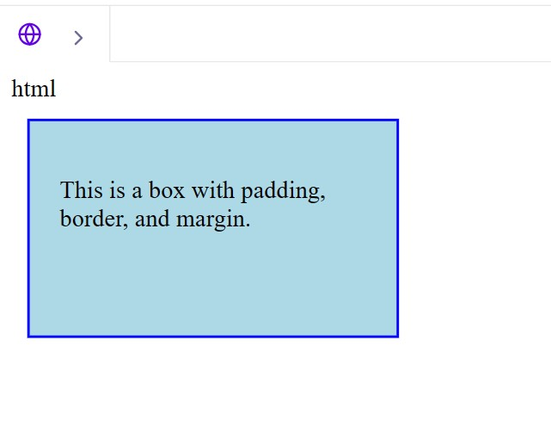

1. Question: Explain the concept of CSS specificity. How is it determined, and why is it important in styling web pages? Exercise: Present a set of HTML elements and CSS rules with varying levels of specificity, and ask students to predict the final styles applied to each element.

CSS specificity is a crucial concept in web development that determines which CSS rules take precedence when styling HTML elements. It defines the hierarchy of importance among CSS selectors and helps the browser decide which styles to apply to elements. Specificity is essential in avoiding conflicts and ensuring that your web page appears as intended.

Specificity is determined based on the combination of selectors in a CSS rule. The more specific a selector is, the higher its specificity value. Specificity is typically calculated using the following criteria, in order of importance:

1. Inline Styles: Inline styles are styles defined directly in the HTML using the style attribute. They have the highest specificity and override any other CSS rules.

2. ID Selectors: Selectors that target HTML elements by their id attribute have a high specificity value.

3. Class Selectors and Attribute Selectors: Selectors targeting classes (e.g., .my-class) and attributes (e.g., [data-attribute="value"]) have medium specificity.

4. Type Selectors and Pseudo-elements: Selectors targeting HTML element types (e.g., div, p) and pseudo-elements (e.g., ::before, ::after) have lower specificity.

5. Universal Selectors and Descendant Selectors: Selectors that target all elements or elements within another element (e.g., \*, div p) have the lowest specificity.

When multiple CSS rules apply to the same element, the browser calculates their specificity values and applies the styles from the most specific rule. If two or more rules have the same specificity, the one that appears last in the stylesheet takes precedence (this is known as the "cascading" part of CSS).

Now, for an exercise to understand CSS specificity, we can present a set of HTML elements and CSS rules with varying levels of specificity. Here's an example:

html

<!DOCTYPE html>

<html>

<head>

<style>

#special-paragraph {

color: red;

}

p {

color: blue;

}

.important {

color: green;

}

</style>

</head>

<body>

<p id="special-paragraph" class="important">This is a paragraph.</p>

</body>

</html>

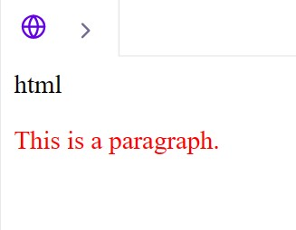

1. Question: What are CSS Flexbox and CSS Grid? Describe when you would use each layout model, and provide an example of both. Exercise: Ask students to create a webpage layout using CSS Flexbox and another using CSS Grid, and compare the differences in the resulting layouts.

ANSWER) CSS Flexbox and CSS Grid are two layout models in CSS that allow web developers to create responsive and flexible page layouts. They each have their own strengths and use cases:

1. CSS Flexbox (Flexible Box Layout):

- Flexbox is primarily used for one-dimensional layouts, such as arranging items in a row or column.

- It's great for creating dynamic and flexible layouts when the size of the items within a container is unknown or dynamic.

- Flexbox is ideal for navigation menus, card layouts, and centering content vertically or horizontally.

Example of using Flexbox:

html

<!DOCTYPE html>

<html>

<head>

<style>

.container {

display: flex;

justify-content: space-between;

align-items: center;

}

.item {

flex: 1;

text-align: center;

padding: 10px;

border: 1px solid #000;

}

</style>

</head>

<body>

<div class="container">

<div class="item">Item 1</div>

<div class="item">Item 2</div>

<div class="item">Item 3</div>

</div>

</body>

</html>

In this example, we have a Flexbox container with three items that are evenly spaced and centered within the container.

2. CSS Grid:

- Grid is used for two-dimensional layouts, making it ideal for creating complex grid-based designs.

- It's suitable for designing grid-like structures, such as responsive grid layouts, image galleries, and even entire web page layouts.

Example of using CSS Grid:

html

<!DOCTYPE html>

<html>

<head>

<style>

.container {

display: grid;

grid-template-columns: repeat(3, 1fr);

gap: 10px;

}

.item {

text-align: center;

padding: 10px;

border: 1px solid #000;

}

</style>

</head>

<body>

<div class="container">

<div class="item">Item 1</div>

<div class="item">Item 2</div>

<div class="item">Item 3</div>

</div>

</body>

</html>

In this Grid example, we have a container with three items arranged in a grid with evenly spaced columns and a gap between them.

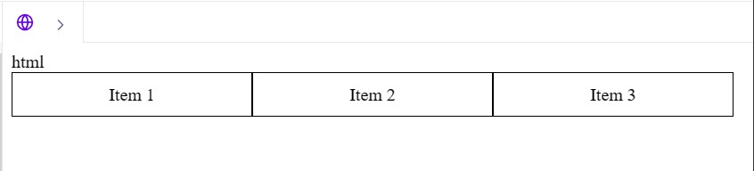

1. Question: Describe the difference between `position: relative`, `position: absolute`, and `position: fixed` in CSS. When and how would you use each of these position values? Exercise: Provide a webpage with elements that need to be positioned using the different values, and ask students to apply CSS to achieve the desired layout.

ANSWER) position: relative:

Elements with position: relative are positioned relative to their normal position in the document flow.

Using properties like top, right, bottom, and left, you can shift the element from its original position while still affecting the layout of other elements.

position: absolute:

Elements with position: absolute are positioned relative to the nearest positioned ancestor (an ancestor with a position value other than static).

Absolute positioning removes the element from the normal document flow, so it doesn't affect the layout of other elements.

It's often used for creating overlays, tooltips, or precisely positioning elements within a container.

position: fixed:

Elements with position: fixed are positioned relative to the viewport, and they remain in the same position even when the page is scrolled.

Fixed elements are used for creating persistent headers, sidebars, or elements that should always be visible on the screen.

Here's an example webpage with elements that need to be positioned using the different values, along with the HTML structure and CSS to achieve the desired layout:

<!DOCTYPE html>

<html>

<head>

<style>

.relative-box {

position: relative;

width: 200px;

height: 100px;

background-color: lightblue;

}

.absolute-box {

position: absolute;

top: 50px;

right: 20px;

width: 150px;

height: 150px;

background-color: lightgreen;

}

.fixed-box {

position: fixed;

top: 20px;

right: 20px;

width: 100px;

height: 50px;

background-color: lightcoral;

}

</style>

</head>

<body>

<div class="relative-box">Relative</div>

<div class="absolute-box">Absolute</div>

<div class="fixed-box">Fixed</div>

</body>

</html>

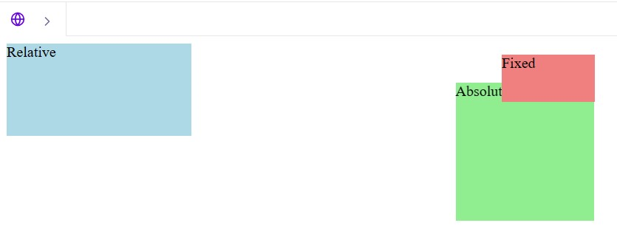

5. Question: Explain the concept of CSS pseudo-elements like `::before` and `::after`. Provide an example where these pseudo-elements are used to enhance the design of a webpage. Exercise: Give students a webpage with specific design requirements and ask them to use pseudo elements to achieve those enhancements.

ANSWER) CSS pseudo-elements, such as ::before and ::after, are used to create elements that are not present in the HTML structure but are added to the document for styling purposes. These pseudo-elements can be used to enhance the design and layout of a webpage by inserting additional content or decorative elements.

Here's a brief explanation of these pseudo-elements:

::before:

The ::before pseudo-element is used to insert content before the content of an element.

It is often used for adding decorative elements or textual content to an element.

::after:

The ::after pseudo-element is used to insert content after the content of an element.

Like ::before, it is also commonly used for decorative elements, such as icons or additional text.

Here's an example of how these pseudo-elements can be used to enhance the design of a webpage:<!DOCTYPE html>

<html>

<head>

<style>

.box {

width: 200px;

height: 200px;

background-color: lightblue;

position: relative;

}

.box::before {

content: "Before";

position: absolute;

top: 10px;

left: 10px;

background-color: lightgreen;

padding: 5px;

}

.box::after {

content: "After";

position: absolute;

bottom: 10px;

right: 10px;

background-color: lightcoral;

padding: 5px;

}

</style>

</head>

<body>

<div class="box"></div>

</body>

</html>

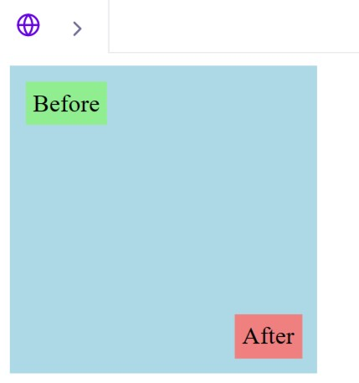

6.Question: What is responsive web design, and how can media queries be used to create responsive layouts? Provide an example of a responsive webpage. Exercise: Provide a basic webpage and ask students to create a responsive design using media queries to adapt the layout for different screen sizes.

ANSWER) Responsive web design is an approach to web design that makes web pages render well on various devices and screen sizes. The goal is to create a user-friendly and visually appealing experience, regardless of whether a user is viewing a website on a desktop, tablet, smartphone, or other devices. Media queries are a key technique used to create responsive layouts.

Media queries are CSS rules that allow you to apply different styles or layout rules based on the characteristics of the user's device or viewport. They can be used to target specific screen widths, device orientations, or other conditions. Here's an example of a media query:

@media screen and (max-width: 768px) {

/\* CSS rules for screens with a maximum width of 768px \*/

}

To create a responsive webpage, you can use media queries to adjust the layout, font sizes, spacing, and other design elements as the screen size changes. Here's a simple example of a responsive webpage:

html

<!DOCTYPE html>

<html>

<head>

<meta name="viewport" content="width=device-width, initial-scale=1.0">

<style>

body {

font-family: Arial, sans-serif;

margin: 0;

padding: 0;

}

header {

background-color: #333;

color: #fff;

text-align: center;

padding: 20px;

}

main {

padding: 20px;

}

@media screen and (max-width: 768px) {

header {

font-size: 1.5em;

}

main {

font-size: 1.2em;

}

}

</style>

</head>

<body>

<header>

<h1>Responsive Web Design</h1>

</header>

<main>

<p>This is a simple example of a responsive webpage. As the screen width decreases, the font size of the header and main content will decrease.</p>

</main>

</body>

</html>

In this example, a media query is used to adjust the font size when the screen width is 768px or less. The header and main content's font sizes are decreased to improve the readability on smaller screens. The viewport meta tag is also added to ensure proper scaling on mobile devices.

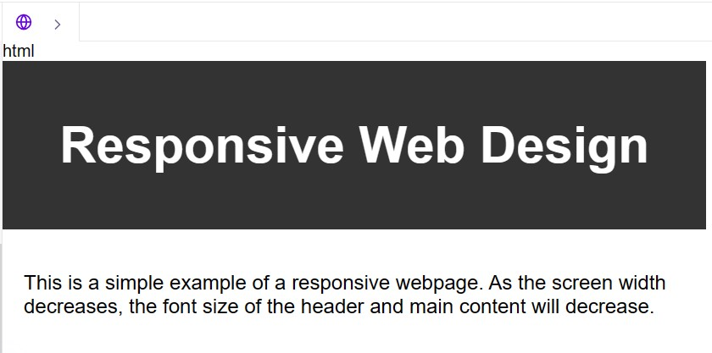

7. Question: Discuss the importance of accessibility in web development. Explain ARIA roles and attributes, and provide an example of making a webpage more accessible. Exercise: Offer a webpage with accessibility issues, and ask students to improve its accessibility by adding ARIA roles and attributes.

ANSWER) Accessibility in web development is the practice of ensuring that web content and applications are usable by people with disabilities. It's a critical aspect of web design and development because it promotes inclusivity and allows all users, regardless of their abilities, to access and interact with web content. Here are some reasons why accessibility is important:

Inclusivity: Ensuring accessibility means making the web available to a broader range of users, including those with visual, auditory, motor, and cognitive disabilities.

Legal and Ethical Requirements: Many countries have laws and regulations that require websites to be accessible. Non-compliance can lead to legal issues and penalties.

Improved User Experience: Implementing accessible features often results in a better user experience for all users, not just those with disabilities.

Search Engine Optimization: Accessible websites are often better indexed by search engines, which can improve search engine rankings.

ARIA (Accessible Rich Internet Applications) roles and attributes are a set of attributes that can be added to HTML elements to provide extra information to assistive technologies, such as screen readers. ARIA helps in making web content more accessible by enhancing the semantics of elements and providing additional information about their purpose and behavior.

Here's a simple example of a webpage more accessible using ARIA roles and attributes:<!DOCTYPE html>

<html>

<head>

<title>Accessible Webpage Example</title>

</head>

<body>

<header>

<h1>Welcome to Our Website</h1>

<nav role="navigation" aria-label="Main Navigation">

<ul>

<li><a href="#">Home</a></li>

<li><a href="#">About</a></li>

<li><a href="#">Services</a></li>

<li><a href="#">Contact</a></li>

</ul>

</nav>

</header>

<main>

<h2>About Us</h2>

<p>This is the main content of our website.</p>

</main>

<footer>

<p>&copy; 2023 Example Company</p>

</footer>

</body>

</html>

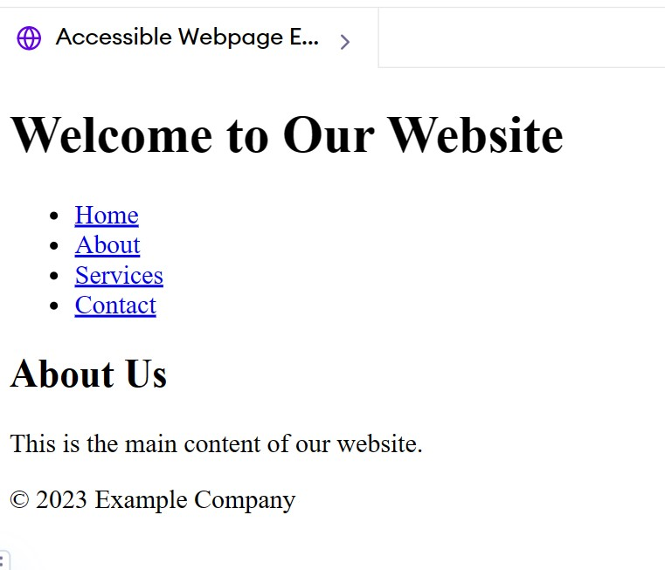

8. Question: What is the purpose of the `<DOCTYPE>` declaration in HTML, and how does it affect the rendering of a webpage in different browsers? Exercise: Ask students to create a simple HTML document and experiment with different `<DOCTYPE>` declarations to observe how they affect the rendering in various browsers.

ANSWER) The version of HTML or XHTML that a web document is utilizing is specified by the declaration in HTML (Hypertext Markup Language). It provides guidance on how to interpret the document's markup to web browsers and other technologies. The declaration's goal is to guarantee accurate and consistent online page presentation across various web browsers. The rendering engines of various web browsers translate HTML and CSS to show web content. When a declaration is proper and valid, the browser will render the webpage in a manner complying with standards, according to the guidelines and conventions that are specific to the stated HTML or XHTML version.This helps maintain consistency and predictability in how the webpage is displayed across different browsers and devices.

<!DOCTYPE html>

<html>

<head>

<title>Experimenting With Doctype</title>

<style>

Body{

font-family:’Arial’,sans-serif;

text-align:center;

margin:50px;

}

</style>

</head>

<body>

<h1>DOCTYPE Experiment</h1>

<p>This is a simple HTML document to experiment with different DOCTYPE declerations.</p>

</body>

</html>

